Department stores need to analyze their customer, because of that the system needs to store the customer data buying behavior. So, department stores need to collect customer data, transaction data, and also the product data.

Task

**NB**:

Pada ketiga table terdapat column/field **Time_Created** and **Update_Time**. Dan pada Table **Transaksi** terdapat field **Tanggal_Transaksi**. Semua Field tersebut menggunakan **CURRENT_TIMESTAMP** data type with “**on update**” turned off. Khusus untuk **Update_Time**, fitur “**on update**” dinyalakan.

1. Create ERD for the flow above.

2. Create query to get best seller product for male and female.

3. Create query to get customer that spends the most money.

4. Create query to show number of transactions for every 2 hours.

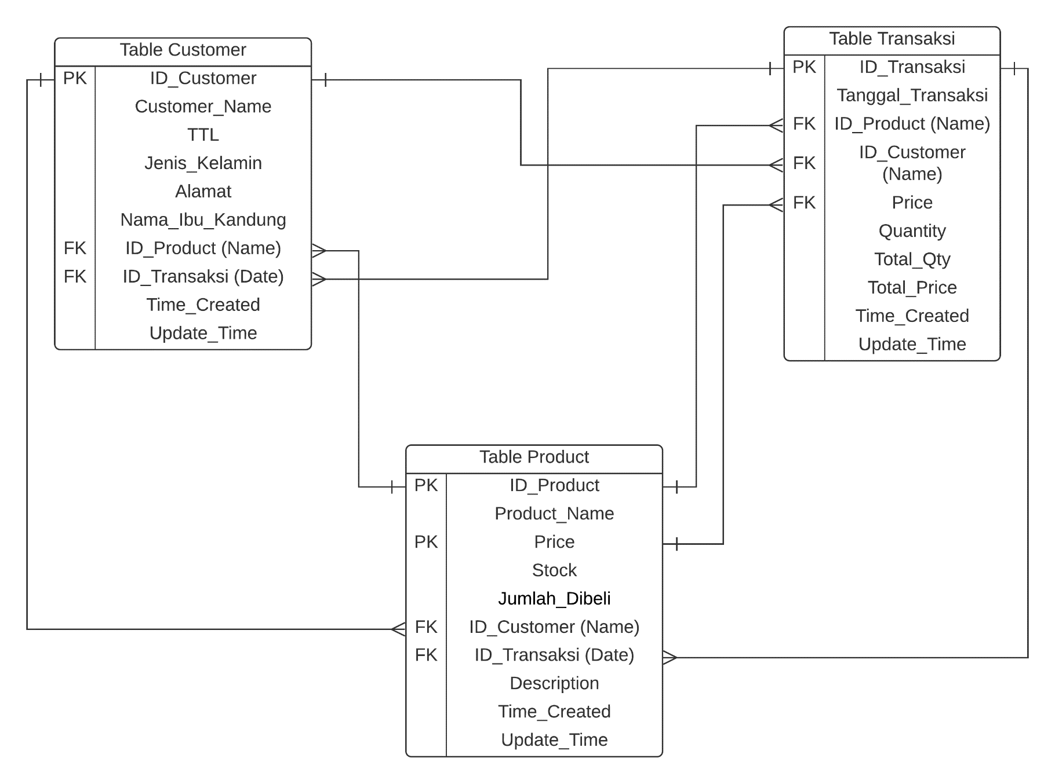

Gambar 1 ERD (Entity Relation Diagram)

No. 2 🡪 create Query to get best seller product for male and female.

**SELECT Product.Product_Name FROM Product, Customer WHERE Product.Jumlah_Dibeli = max(Product.Jumlah_Dibeli) AND Product.ID_Customer = Customer.ID_Customer AND Product.ID_Product = Customer.ID_Product AND Customer.Jenis_Kelamin = “Laki-Laki”;** 🡪 Query ini untuk mendapatkan best seller product for male.

**SELECT Product.Product_Name FROM Product, Customer WHERE Product.Jumlah_Dibeli = max(Product.Jumlah_Dibeli) AND Product.ID_Customer = Customer.ID_Customer AND Product.ID_Product = Customer.ID_Product AND Customer.Jenis_Kelamin = “Perempuan”;** 🡪 Query ini untuk mendapatkan best seller product for female.

No. 4 🡪 Create query to show number of transactions for every 2 hours.

**COUNT( SELECT ID_Transaksi FROM Transaksi WHERE Tanggal_Transaksi = (CURRENT_TIMESTAMP – 02.00.00) until CURRENT_TIMESTAMP AND Time_Created = (CURRENT_TIMESTAMP – 02.00.00) until CURRENT_TIMESTAMP; );**

No.3 🡪 Create query to get customer that spends the most money

**SELECT Customer.Customer_Name FROM Customer, Transaksi WHERE Transaksi.ID_Customer = Customer.ID_Customer AND Transaksi.ID_Transaksi = Customer.ID_Transaksi AND Transaksi.Total_Price = max(Transaksi.Total_Price) AND count(Transaksi.Customer_ID AND max(Transaksi.Total_Price));**